Practical No. 17
Aim : 1) Write java program to Demonstrate Grid of 5*5.

Name : Danish Altaf Solkar | Class : CO - B
Enrolment no. : 24111590805 | Batch : 2

Code :-
import javax.swing.*;
import java.awt.*;
public class prac17 {
public static void main(String[] args) {
JFrame frame = new JFrame("5x5 Grid Example");
frame.setDefaultCloseOperation(JFrame.EXIT_ON_CLOSE);
frame.setLayout(new GridLayout(5, 5));
for (int i = 0; i < 25; i++) {
JButton button = new JButton("Button " + (i + 1));
frame.add(button);
}
frame.setSize(400, 400);
frame.setVisible(true);
}
}

OUTPUT :-
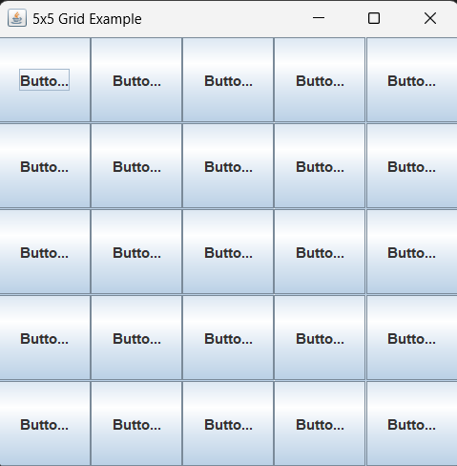

Aim : 2) Write a program to display the number on Button from 0 to 9.

Code :-
import java.awt.*;
public class NumberButtonGUI {
public static void main(String args[]) {
Frame f = new Frame();
f.setSize(400, 400);
f.setVisible(true);
f.setLayout(new GridLayout(5, 2, 10, 10));
int b = 0;
for (int i = 0; i < 10; i++) {
f.add(new Button("" + b));
b++;
}
}

OUTPUT :-
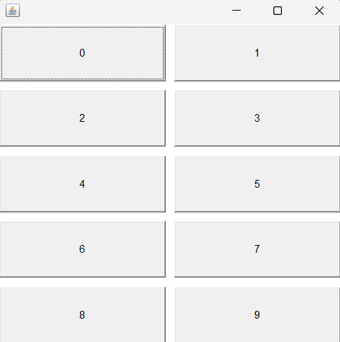

Aim : 3) Write a program to generate following output.

Code :-
import java.awt.*;
public class NumberButtonGUI {
public static void main(String args[]) {
Frame f = new Frame();
f.setSize(400, 400);
f.setVisible(true);
f.setLayout(new GridLayout(3, 2, 10, 10));
int b = 1;
for (int i = 0; i < 5; i++) {
f.add(new Button("Button" + b));
b++;
}
}
}

OUTPUT :-
